**Machine Learning with AWS Deep Composer**

In this lesson you'll get an introduction to Machine Learning. You will learn about Generative AI and AWS DeepComposer. You'll also learn how to build a custom Generative Adversarial Network.

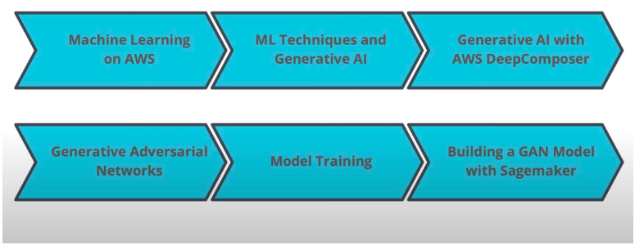

**Why Machine Learning on AWS?**

## AWS Mission

Put machine learning in the hands of every developer.

### Why AWS?

* AWS offers the broadest and deepest set of AI and ML services with unmatched flexibility.
* You can accelerate your adoption of machine learning with AWS SageMaker. Models that previously took months and required specialized expertise can now be built in weeks or even days.
* AWS offers the most comprehensive cloud offering optimized for machine learning.
* More machine learning happens at AWS than anywhere else.

[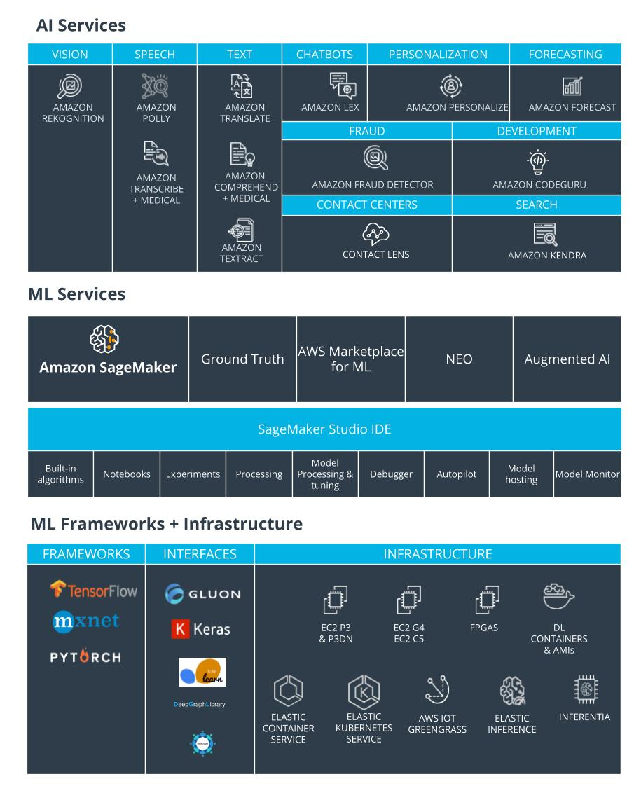](https://classroom.udacity.com/courses/ud090/lessons/099925a2-4f01-41c7-a4d4-8ce246f7b801/concepts/f8cb43fe-de2a-4948-837c-0a2001566ca4)

**[AWS Machine Learning Stack](https://classroom.udacity.com/courses/ud090/lessons/099925a2-4f01-41c7-a4d4-8ce246f7b801/concepts/f8cb43fe-de2a-4948-837c-0a2001566ca4)**

**More Relevant Enterprise Search With Amazon Kendra**

* Natural language search with contextual search results
* ML-optimized index to find more precise answers
* 20+ Native Connectors to simplify and accelerate integration
* Simple API to integrate search and easily develop search applications
* Incremental learning through feedback to deliver up-to-date relevant answers

### Online Fraud Detection with Amazon Fraud Detector

* Pre-built fraud detection model templates
* Automatic creation of custom fraud detection models
* One interface to review past evaluations and detection logic
* Models learn from past attempts to defraud Amazon
* Amazon SageMaker integration

### Amazon Code Guru

**[[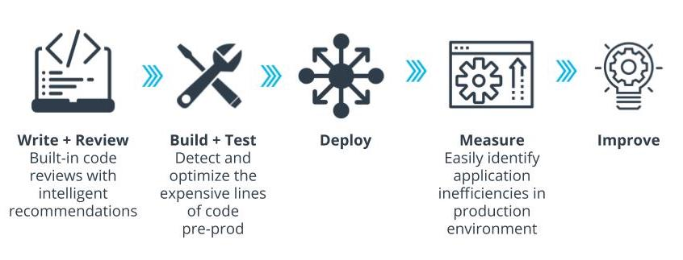](https://classroom.udacity.com/courses/ud090/lessons/099925a2-4f01-41c7-a4d4-8ce246f7b801/concepts/f8cb43fe-de2a-4948-837c-0a2001566ca4)](https://classroom.udacity.com/courses/ud090/lessons/099925a2-4f01-41c7-a4d4-8ce246f7b801/concepts/f8cb43fe-de2a-4948-837c-0a2001566ca4)**

**[Amazon CodeGuru For High-performing Software](https://classroom.udacity.com/courses/ud090/lessons/099925a2-4f01-41c7-a4d4-8ce246f7b801/concepts/f8cb43fe-de2a-4948-837c-0a2001566ca4)**

### Better Insights And Customer Service With Contact Lens

* Identify common call types
* Identify recurring themes based on customer call feedback
* Alert supervisors when customers are having a poor experience
* Assist agents with a knowledge base to answer questions as they are being asked

### How to Get Started?

* [**AWS DeepLens**](https://aws.amazon.com/deeplens/): deep learning and computer vision
* [**AWS DeepRacer**](https://aws.amazon.com/deepracer/) and the [**AWS DeepRacer League**](https://aws.amazon.com/deepracer/league/): reinforcement learning
* [**AWS DeepComposer**](https://aws.amazon.com/deepcomposer/): Generative AI.
* [**AWS ML Training and Certification**](https://aws.amazon.com/training/learning-paths/machine-learning/): Curriculum used to train Amazon developers
* Partnerships with Online Learning Providers: Including this course and the Udacity [**AWS DeepRacer**](https://www.udacity.com/course/aws-deepracer--ud014) course!